JITENDER KUMAR

Graphic Designer

About Me

# Experience

A seasoned video editor with a focus on project management, post- production, video editing, and visual effects. an

established track record o overseeing video production jobs and working with creative teams to improve storytelling, is

skilled at turning long-form content into short films.

+91 8447070911

[jitenderkumar20890@gmail.com](mailto:jitenderkumar20890@gmail.com)

Data Annotation

Digiyoda

.Quality control : Conduct thorough quality checks on annotated data to identify and rectify errors or inconsistencies, maintaining high data

quality standards.

Graphic Designer

Evolve Digitas, Nodia, Uttar pardesh

1. month
2. month

Mandawali, Delhi

# Language

Hindi

I have designed and delivered motion graphics for a range of media.Working with the art and creative teams, I enhance video footage by

adding effects and components and choosing music, video, colors, animation, etc. for graphic design. keeping up with the latest graphic design

developments

Infolatop.in

English

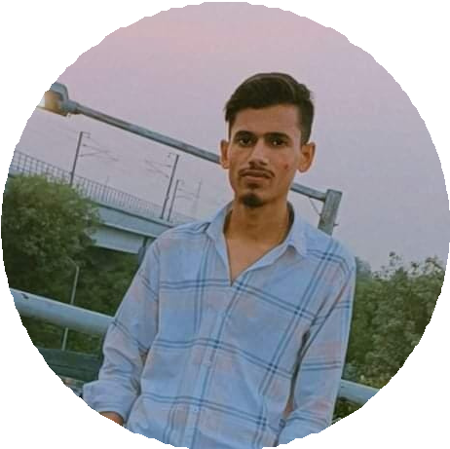

# Expertise

Management Skills Creativity Photoshop

After Effects Premiere Pro

[https://youtube.com/@jitender](https://youtube.com/%40jitender) kumar5182

Poster designer and Video Editing

Produce high-quality graphics and artwork using industry- standard design software such as Adobe Creative Suite (Photoshop, Illustrator, Premiere Pro, After Effects etc.).

Prepare designs for print or digital distribution, ensuring proper file formats and specifications.

# Education

10th Pass from CBSE BOARD Delhi in 2016

12th Pass from NIOS BOARD Delhi in 2020

1 YEAR GRAPHIC DESIGNER FROM MAAC INSTITUTE

B.A Pass from Delhi University in 2024

6- month