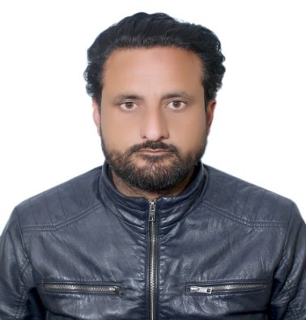 |  | SABOOR AHMAD  SALES AND MARKETING
Profile  Skilled in building cross-functional teams, demonstrating exceptional communication skills, and making critical decisions during challenges. Adaptable and transformation leader with an ability to work independently, creating effective presentations organizational goals.  Contact  PHONE:  +91 8707654805  EMAIL:  SABOORAHMAD574@GMAIL.COM  Trainings  TEAM HANDLING  SALES BOOSTER |  | EDUCATION  UNITY COLLEGE  2003 - 2004  HIGHSCHOOL  2005-2006  INTERMEDIATE  LUCKNOW CHIRSTIAN COLLEGE  2006 - 2009  BACHELOR OF COMMERCE  WORK EXPERIENCE  INDIAN SAFETY SERVICES SALES HEAD  FEB 2019–CURRENTLY WORKING  ROTEX CONTROLS SALES MANGER  JAN 2014–JAN 2019  PRIME SAFETY AND EQUIPMENTS SALES OFFICER  DEC 2012- JAN 2014  RELIANCE LIFE INSURANCE LTD SALES OFFICER  AUG 2009- SEPTEMBER 2011  SAHARA AIR CONDITIONING WLL SALES EXECUTIVE  NOV 2011- NOV 2012SA  CERTIFICATION  IELTS FORM BRITISH COUNCIL OF KUWAIT  NEBOSH IGC  ADVANCE DIPLOMA COMPUTER APPLICATION

